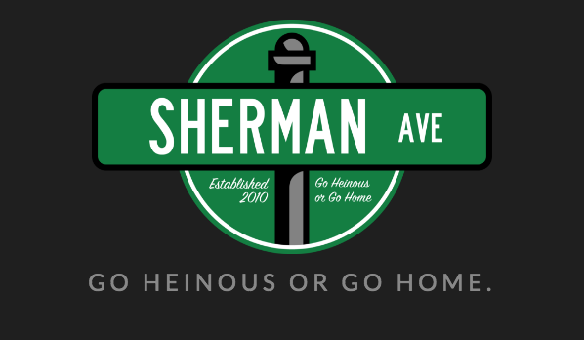
Application due by
11:59 PM on
Friday, October 7th
Please export all written application, short answer, and prompt responses onto one PDF to attach in an email with the subject “[Name]’s Sherman Ave Application”
Submit your finished application and any questions/concerns to shermanave1@gmail.com

Name:

Year:

School*:

Major(s)/Minor(s):

Hometown:

Phone Number:

Special Talents:

*You do NOT have to attend Northwestern University to write for Sherman Ave.

1) Mr. Brightside comes on at a party. Describe your reaction.

2) What really happened the night Ryan Lochte was supposedly robbed? Use as much detail as possible.

3) How do you want to die? (You CANNOT say old age).

4) In no more than a paragraph, explain why you want to be a part of Sherman Ave #FeeltheSherm.

5) Write three headlines for Sherman Ave

6) Write three tweets for Sherman Ave.

Prompt 1: Write an article about one of the five following topics. (Max 500 words)
-A Freshman Guide to ___________
-STITCH Announces Fall's Hottest Trend Is _______
-It Happened to Me: My PA Group was _________
-Everyday Hero: This Anonymous Student Did _______
- New ____ In Norris

Prompt 2: Describe your strengths in multimedia (and your weaknesses as a lover). We are looking for creative minds also skilled at multiple forms of media. Please attach a multimedia piece. It can be a video, a PhotoShopped picture, a song, a podcast, a photo story, a crappy MS paint image—really anything.

