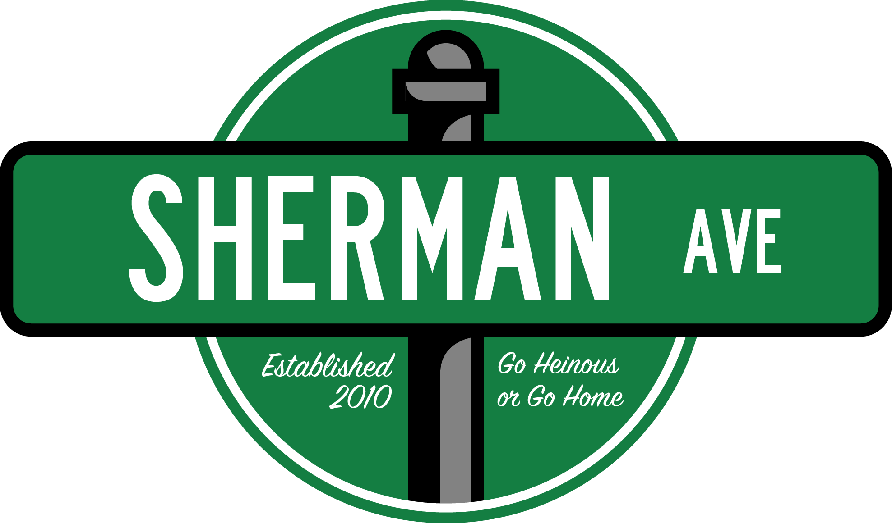
Media Team Application due by
5:00 PM on
Friday, October 6th
Please export all written application, short answer, and prompt responses onto one PDF or Microsoft Word document file to attach in an email with the subject “[Name]’s Sherman Ave Media Team Application”
Submit your finished application and any questions/concerns to shermanave1@gmail.com
What is the Sherman Ave Media Team?
Sherman Ave is launching a brand new (and disgustingly heinous) media team! Are you a self-sufficient RTVF student who's too weird to make normal movies? Are you a Medill student who secretly hates real news? Are you a Communications student who needs new friends? Well this is the group for you!

The team will work with writers to create satirical video pieces, as well as photo and web related content to be distributed through the Sherman Ave website and social media pages. We are looking for people with well-rounded digital media experience, a passion for comedic content, and a heinous sense of humor.

Producers, directors, editors, graphic designers, cinematographers, and web developers are all welcome to apply! We want a group of people with many areas of expertise for a fully formed digital media team.

Name:
Year:
School*:
Major(s)/Minor(s):
Hometown:
Phone Number:
Special Talents:

*You do NOT have to attend Northwestern University to write for Sherman Ave.

Time to get vulnerable: In no more than a paragraph, explain why you want to be a part of Sherman Ave. What separates you from all the other dweebs applying?

Wow thank you for being so open you big wuss. Now that that’s over:

Please attach your resume, or a list of past filmmaking/graphic design experience. A list of skills would also be ~sick~:

Put links to past work here. You may also attach any files to your email:

Congrats! You did it! Wow, that sure was easy! Now send over this sucker and enjoy a nice cold beverage as a reward for a job well done.

