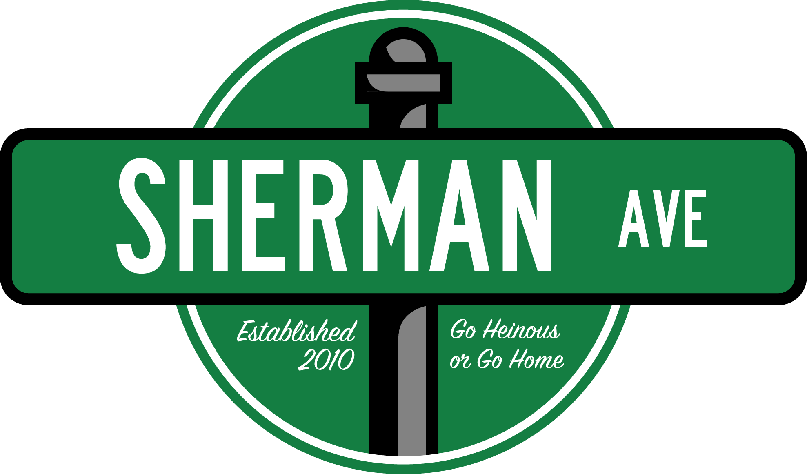
Writers Application due by
5:00 PM on
Friday, October 6th
Please export all written application, short answer, and prompt responses onto one PDF or Microsoft Word document file to attach in an email with the subject “[Name]’s Sherman Ave Writers Application”
Submit your finished application and any questions/concerns to shermanave1@gmail.com

Name:
Year:
School*:
Major(s)/Minor(s):
Hometown:
Phone Number:
Special Talents:

*You do NOT have to attend Northwestern University to write for Sherman Ave.

Short Answer! Choose 5 (Five) of the 9 (Nine) prompts and answer those suckers.

1) Willie the Wildcat was found dead floating face-first in a swamp outside of Naperville. Who dunnit and why?
2) In ten words or fewer, explain to your child why God is a lie.
3) Be honest.
4) Describe, in extremely vivid detail, your mother’s womb (sounds, visuals, texture, etc.).
5) You’re on your first date with Morty Schapiro. What do you do?
6) Congress decides ‘The Star-Spangled Banner’ must be replaced. What is our new national anthem?
7) On a scale of airport luggage to Steve Buscemi, how “woke" are you? (please explain your reasoning)
8) Congrats! You aced the first midterm of the year! How would you kill your father?
9) If you could have sex with any building on campus, which one would it be and why?

Time to get vulnerable: In no more than a paragraph, explain why you want to be a part of Sherman Ave. What separates you from all the other dweebs applying?

Wow thank you for being so open you big wuss. Now that that’s over:
Write three headlines for Sherman Ave:

Write three tweets for Sherman Ave:

Article Prompt #1! Write an article using one of the following prompts. (Max 500 words):

- Review of Sorts (dining hall, campus event, etc.)
- Help! I’m a _____ Stuck in _____’s Body!
- A Freshman Guide To ________
- An Open Letter to _________
- A Day in the Life of ______
- Sleeping with the Enemy: My Time as an Undercover _______

Article Prompt #2! Write an article about whatever you want. (Max 500 words):

Congrats! You did it! Now send over this sucker and enjoy a nice cold beverage as a reward for a job well done.

